Beauty therapist who offered 'vampire facelifts' held over death of client
Sandra Perez Gonzalez was arrested on suspicion of possessing controlled substances after one of her customers had a heart attack in her salon
Long Beach Police Department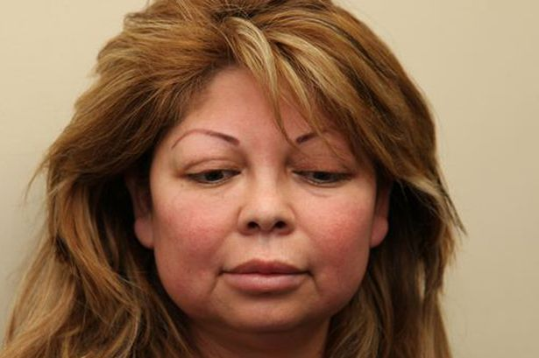
Arrested: Sandra Perez Gonzalez
A beauty therapist who carried out “Vampire Facelifts” is being held in an American jail over the death of a woman she was treating.
Licensed Sandra Perez Gonzalez, 46, was arrested after customer Hamilet Suarez had a heart attack in her treatment salon and massage parlour in California’s Long Beach.
Paramedics tried to revive 36-year-old Hamilet but she failed to respond to CPR.
As well as providing massages, Gonzalez also advertised Vampire Facelifts, butt augmentation, and lip augmentation procedures, police said.
Gonzalez was arrested by police probing Ms Suarez’s death on suspicion of possessing controlled substances.
She is being held on $10,000 (£6,000) bail.
Detectives discovered medical equipment and multiple phials of controlled substances which Gonzalez was not licensed to administer in the treatment room she rented in the Areli’s Beauty Salon on Pacific Avenue. Long Beach police are also trying to track down other customer’s treated by Gonzalez.
http://www.mirror.co.uk/news/weird-news/beauty-therapist-who-offered-vampire-3144813#ixzz2tRIjedNB
Follow us: @DailyMirror on Twitter | DailyMirror on Facebook

